Position vs. Time Graphs & Speed vs. Velocity – Ch 8.2

From last class we were able to describe the motion of a walking person graphically. What did the slopes of the graphs represent?

How to find the magnitude of the slope:

Slope =

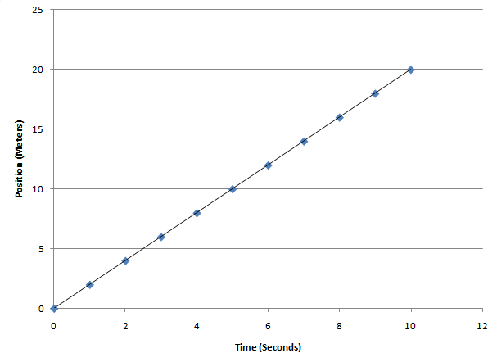

- Pick two points on the grid.

- Make a triangle

4. Units = metres/second

Speed:

Velocity:

Position vs. Time Graphs

This graph describes the motion of an object.
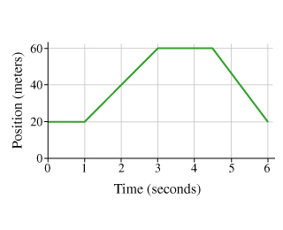

The _____________ ___________ is the slope from the start, to the end of a time period.

Find average velocity in the time interval from 1s-3s.

Find average velocity in the time interval from 3s-4.5s.

Find average velocity in the time interval from 4.5s-6s.

Find the average velocity over the whole movement (0s-6s).

On a position time graph:
- A positive slope means that the object’s average velocity is
- A negative slope means that the object’s average velocity is
- Zero slope means the object’s average velocity is
Calculating Speed and Velocity

Speed Velocity

Examples:

Tim is running away from a bear. He runs 30m East in 2.45s. What is Tim’s velocity?

The bear is chasing Tim to give Tim back his hat that he left in the woods. The bear ran 42m East in 2.88s. What is the bear’s velocity?

Examples:

Tim sprints to leap over a ravine. He leaps at a velocity of 16m/s South and flies in the air for 0.74s. How far did Tim jump?

The bear tries to jump after Tim. The bear leaps at a velocity of 15m/s South and flies for 0.34s. How far did the bear jump?

Examples:

Tim doesn’t make the jump, but hits the side of the ravine. He slides down the 32m of wall at a speed of 1.5m/s down. How long did Tim slide down the wall?

The bear didn’t make it to the other side of the ravine and plummets to the bottom. The bear falls 32m down at a velocity of 13m/s down. How long did the bear fall into the ravine.
(Don’t worry, it fell into some bushes or water or something. The bear is fine.)

Converting m/s and km/h

Homework: p.367 Activity 8-2B, p.375 Check Your Understanding

