Pressure

Vocab – Pressure, Explosion, Implosion, Compression, Deformation

Pressure:

Gas particles are always ____________ quickly and bouncing off ______________ and the ___________ of the container. Particles striking the sides of the container and provide a ____________ on the wall. The _______ of the gas particles on the walls of the container is __________.
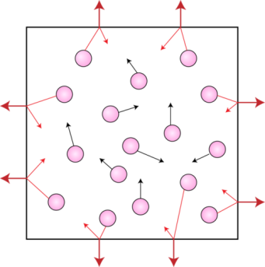

Containers of gas have pressure coming from ___________ and the ____________. The pressure from the gas ___________ the container pushes ____________. The pressure from the outside air pushes _________.
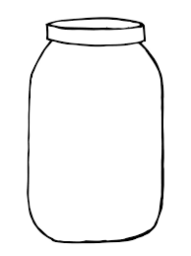

_________________ ________________
Calculating Pressure

Pressure Formula:

Unit:

Pressure Calculation Problems:
A person steps on a nail by accident. The person puts their weight on the step (530N). The point of the nail has an area of 0.00001m². What is the pressure of the nail on the person’s foot?

A different less accident prone person lies down on a bed of nails. They put their full weight (530N) on a 0.53m² area of nails. What is the pressure of the nails on the person’s body?

Compression:

When a substance is compressed the particles are moved __________

Gas ____________ space between the particles, _________ of movement Gas __________ be compressed

Liquid ___________ space between particles, _________ of movement
Liquid __________ be compressed

Solid ____________ space between particles, _________ of movement
Solid ___________ be compressed

Solids can appear to be _____________ when under pressure, but are actually ____________. ____________________ means a change of shape without changing the volume.

Homework: p.296 Practice Problems #1-3
p.296 Reading Check #1-5
p.299 #1-4,6

