Nuclear Reactions

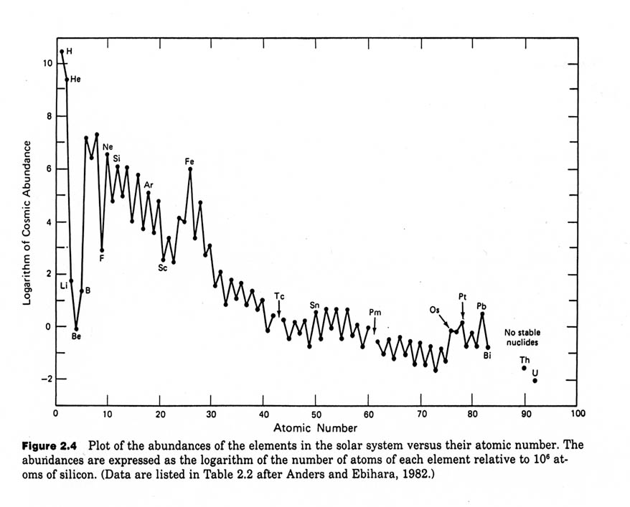
Studies of the nucleus of atoms can help us explain what we see in our environment.

From this chart, we can see a notable trend about the abundance of elements in our Universe.

Though there are some weird points:

Binding Energy: the energy that is used to keep the nucleus together.

Induced Nuclear Reactions

To start a nuclear reaction we ______________________ an atom with ____________ or ____________.

Example:

Nuclear Equation Rules:
- The mass numbers on either side of the arrow will add to the same number.
- The charge (atomic numbers) of either side of the arrow will add to the same number.

Example: the fission of Uranium

Fission | Fusion

