Fluids and Density

Density:

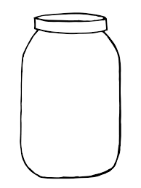
Solid Liquid Gas

Total Mass: Total Mass: Total Mass:

Mass Inside Mass Inside Mass Inside
the Volume: the Volume: the Volume:

Density: Density: Density:

Density Relation:

When an object heats up

When an object cools down

Layering Fluids

Denser fluids will _____________, less dense fluids will _______________.

Dense objects _______________, less dense objects _____________.

How to Measure Density

Formula:

To find the density you would:

To find the volume of weird shaped objects, you could:

What is the density of a 300 g object that takes up 30 cm³ of space?

An object has a density of 24 kg/L. What is the mass of 3.4 L of it?

Homework p.265 #1-3
p.271 #1-5

