Kinetic Molecular Theory

Vocab – solid, liquid, gas, kinetic energy, thermal energy, heat, temperature, melting, solidification, condensing, evaporating, sublimation, deposition

Kinetic Energy:

Kinetic Molecular Theory
By expanding and testing the particle model of matter, scientists have been able to develop the Kinetic Molecular Theory to explain what is happening with the way particles move in substances.

Kinetic Molecular Theory, or KMT, is based off of these main points:

States of Matter in KMT
Solids:

Liquids:

Gases:

Thermal Energy, Heat and Temperature

Thermal Energy:

Heat:

Temperature:

Touching a warm thing ->

Touching a cold thing ->

Thermal Expansion/Compression
As things warm up the particles move _______, they __________________ more and make more _____________ for themselves. All the particles are doing this, so the object will get ______________.

As things cool down the particles will move _______, they will ___________ less and need less ___________. All the particles are doing this, so the object will get _____________.

Changes of State

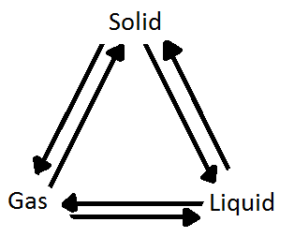

Homework: p.259 #1-10
Add the vocab to the Vocab sheet

