Three Ways of Electrically Charging Materials

There are three ways to charge an object _____________, ___________________, and ____________________.

Charging by ________________ occurs by rubbing two materials together. When rubbed together one of the materials will lose its electrons and the other will gain the electrons.

We see here that when neutral wool is rubbed onto neutral amber, the electrons will “rub off” onto the amber. The amber is then negative because it gained extra electrons and the wool is positive because it lost its electrons.

Charging by _______________ occurs when objects touch and an electric charge is transferred from one object to the other.

Here the charged rod transfers the charge to the electroscope by making contact. The charge transfers and remains on the electroscope.

Charging by __________________ occurs when an object obtains a charge without making contact with another material.
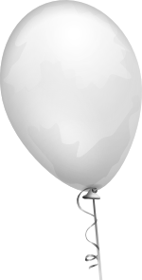
A neutral balloon with equal numbers of positive and negative charges is hanging out.
A charged rod is brought close to the neutral balloon.

As the charged rod is brought closer to the balloon, the like charges repel, pushing them to the far side of the balloon and the unlike charges attract, pulling them to the close side of the balloon. Now the balloon will want to float towards the charged rod!

It is the _________________________________________ which causes neutral objects to be attracted to charged objects.

