Imaging in the Eye and Eye Problems

Pathway of light into our eye:

-Enters the eye through the ____________
-Goes through the opening of the _________ into the __________
-Light is _____________ by the _________
-The light is _____________ onto the ______________
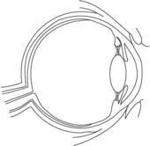

The _____________ around the lens will change its ____________ so it can focus light coming from different ________________ away
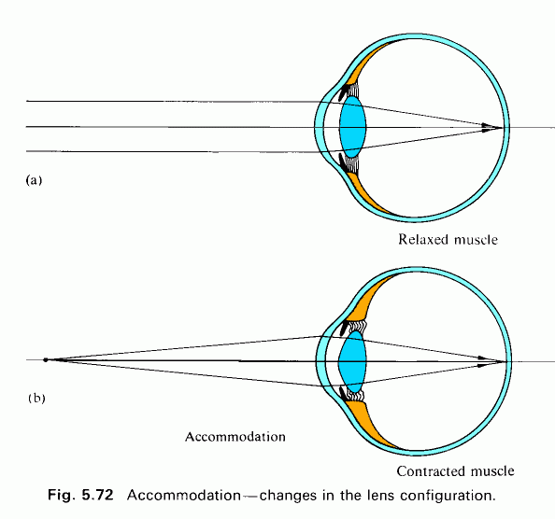

Forming Images

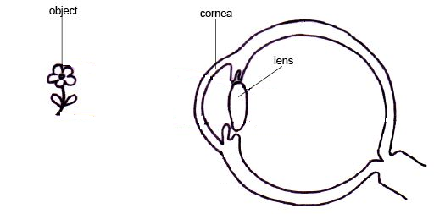

The image on our retina is ____________ ________. The _______ automatically swaps the orientation of the images it sees to give us an accurate representation of what is happening.

Blind spot

Where the _________ ________ meets the eyeball, there are no ________ or ___________. This portion of your eye is where there is a __________ _______.
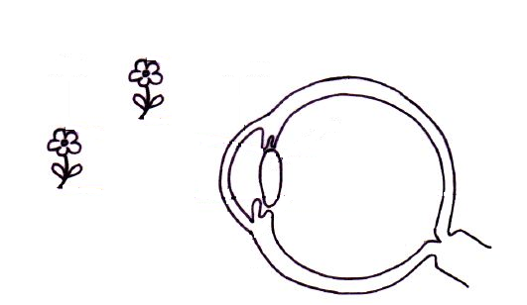
Page 205 in the textbook has a good activity to find your blind spot.
Focusing problems

Near-sighted

People who are near-sighted can see things _________ to them, but things ___________ away are unfocused.
Can be corrected with ___________ lenses
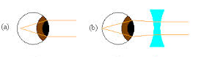

Far-Sighted

People who are far-sighted can see things _________ from them, but things ____________ are unfocused.
Can be corrected with ____________ lenses
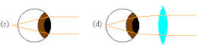

Astigmatism
When somebody has astigmatism their ______________ is distorted in ___________. The light will focus on more than ______ __________ in the eye.
Can be corrected with ____________ _________ or ___________ to reshape the cornea.

Blindness

Blindness can be any vision impairment that keeps people from doing the living their normal life relying on sight. In rare cases, blind people cannot detect any light, but most can perceive a limited amount of light.
Common causes are disease or malnutrition.

Snow Blindness
Snow blindness is caused by ________ __________ to __________ and glare. This can cause inflammation in and around the eye. Resting in a ______ __________ helps recovery from snow blindness.

Night Blindness
A portion of the __________ lose their ability to respond to light. This will reduce the overall effectiveness of the eye’s ability to process light. Low light situations become much harder for the eyes to process.

Colour Blindness
Colour blindness happens when the _________ not responding properly, only ___________________ is colour blind. Colour _____________ is more common, where green-red are hard to distinguish.

Homework p.215 #3,5

