Human Vision - Parts of the Eye

The human eye is an incredible and complex organ. It allows us to see the person sitting next to us, the words on this page, and mountains that are kilometers away.

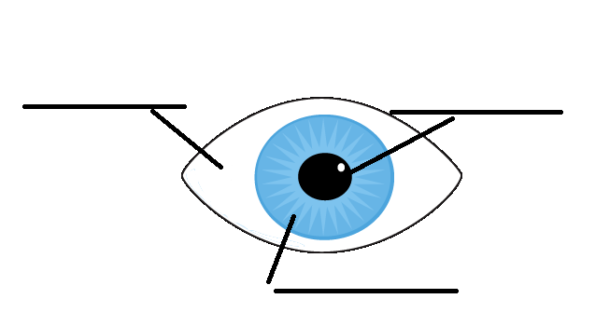

Pupil:

Iris:

Sclera:
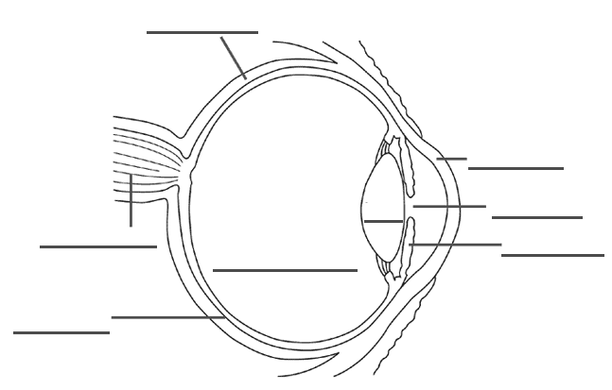
Cornea:

Lens:

Vitreous Humor:

Retina:

Optic Nerve:

The Retina

Cells on your retinas that react to light come in two basic shapes ____ ___________ _________ and _________ __________ ______________.

_________ absorb almost any colour of light, but our brain does not use the signals from these to determine colour, just shades of light and dark. This is what is responsible for _________ ___ ___________ vision. It helps us see in _____ ________ and helps us see ________ and ______________.

__________ allow us to detect colour. We have three kinds of cone cells _____, ________ and ________. Our brain combines and balances the different amounts light absorbed by the _____, ________ and ________ cones to make different colours. An equal amount of light absorbed by all three makes __________ light. We see colour better in bright light because our cones are able to process more light into ____________ ___________ to send to our brain.

Homework p.215 #1,2,4,6,7,8,9

