5.1 – THE CELL CYCLE AND MITOSIS

Why do cells need to divide?

Turn to page 152 of your textbook to find out how often your body’s cells divide!

The life of a cell is divided in to three stages known as the __________ ___________. The three stages are: ___________________, ________________, and _______________________.

Interphase is broken up in to three seperate stages: ___________________________, ________________________________, and __________________________________.

During Cytokinesis, the cell seperates in to two daughter cells.
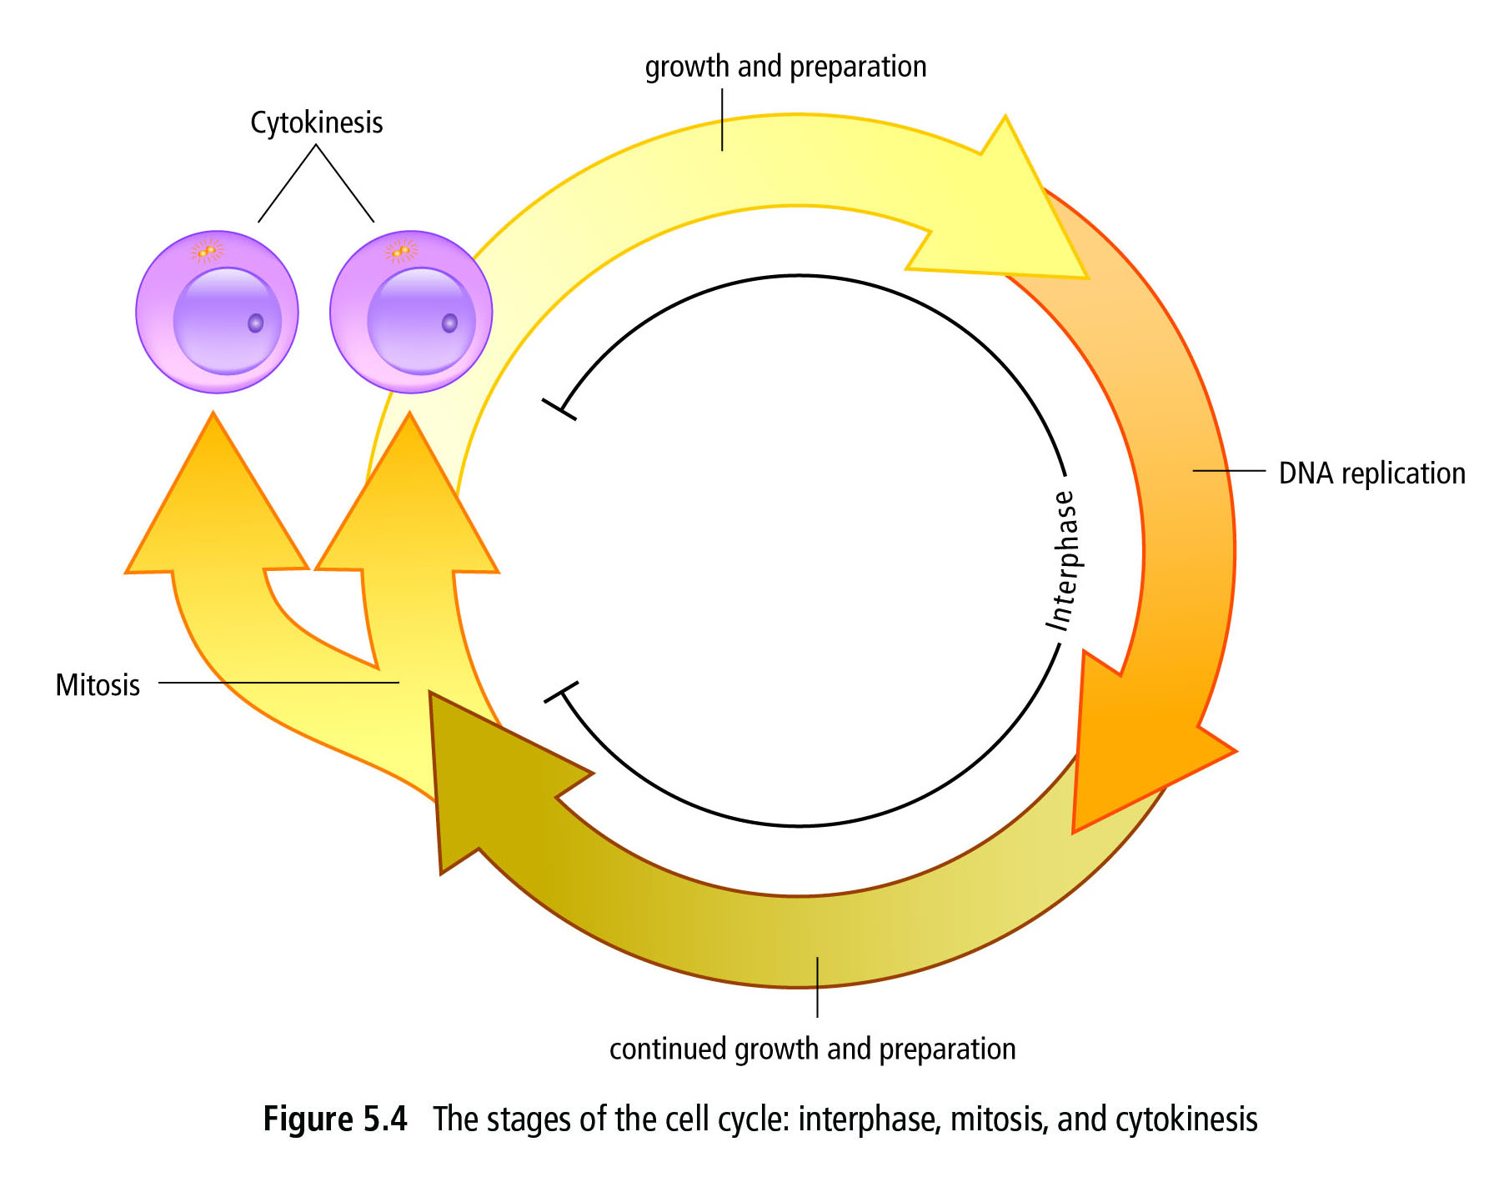
During Mitosis, the contents of the cell are doubled and divided in to two equal parts. This is where MUTATIONS can occur!!
During Interphase, a cell carries out its normal functions. It also prepares for replication.
STAGES OF THE CELL CYCLE:

Name of Cell Cycle Stage: | Cell Activities:
Interphase
Growth and Replication | -Cell increases in size.  -Makes proteins that are necessary for the cell to function.
DNA Replication | -DNA makes a copy of itself so there are two complete sets of DNA.  -DNA must be uncoiled from chromatin!
Continued Growth and Replication | -Organelles are duplicated.  -Materials such as proteins are made for the new cells.
Mitosis
Prophase | -DNA coils in to _____________ ________________ (double chromosome) joined at a __________________.  -Nuclear membrane breaks down.  -_______________ ______________ (made of protein) form from ____________________ .  -Spindle fibres attach to sister chromatids at the centromere.
Metaphase | -Spindle fibres pull the sister chromatids in to a single line across the middle of the cell.
Anaphase | -Spindle fibres contract and shorten. This pulls the sister chromatids apart in to ___________________.  -The DNA is separated in to two equal and identical groups.
Telophase | -Spindle fibres disappear.  -Nuclear membrane forms around each set of chromosomes.
Cytokinesis | -The cell membrane pinches together and the cytoplasm separates.  -Two ______________________ _____________ are formed.
CHECKPOINTS IN THE CELL CYCLE:

The cell cycle has many “checkpoints” to ensure the cell cycle is running smoothly. Special PROTEINS at these checkpoints monitor cell activities and send this information to the nucleus. The nucleus then tells the cell if it can divide or not.

Cells will not divide if:

Look on page 159 of your textbook to see specific checkpoints in the cell cycle!

Complete the following Questions using Pages 159-161 of your textbook.
QUESTION | ANSWER
Why is it important that
there be checkpoints in the
cell cycle?

What is the name given to diseases that result from uncontrolled cell division?

What causes a cell to lose control of the cell cycle and become cancerous?

How does a cancer cell look
compared to a normal cell?

Why do we call cancer cells “unspecialized”?

How does cancer spread to other parts of the body?

