Visible Light and Colour

Most light we use (like sunlight or ceiling lights) is what we call _____________ light. It is light, that when shone onto a white background, with look white. We can look at what white light is made of by using the property of ______________.

Refraction:

Example: Refraction of visible light

Red Green Blue
Wavelength

Refraction

Isaac Newton’s Experiment
People believed that colour was something an object added to white light. So, when white light strikes a blue shirt, the shirt would give the blue colour to the light. Newton made an experiment to see whether this was right or wrong.
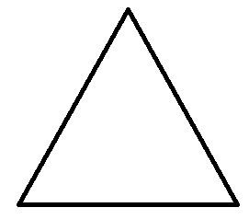

What is the colour of the prism?

What colour could the prism give to light?

What results do we get?

What does this mean?

Reflection and Colour

Our eyes see by having light go into them.

Thought experiment: If you were placed in a cell 30 m underground through windy passages and sealed into a room with no lights inside, would your eyes adjust to the darkness so you could see a little bit?

If there is no light, you will ____________________________.
If there is a little light, you will ________________________________.

Light rays make it into our eyes by __________________ off an object and heading into our eyes. How would this help us see colour if we are shining white light on an object?

When light hits an object, the object will absorb most of the coloured light, and reflect the rest. Remember, we can only see the light that is reflected.

So:

A blue shirt will reflect __________ light and absorb __________________

A red hat will reflect _________ light and absorb _____________________

A green booger will reflect ________ light and absorb _________________

Absorbing light will make __________. Compare wearing a white shirt and a black shirt in the sun.

Combining Light
We can combine coloured light to make different colours of light. Write the result of each combination:

Green light + Blue light =

Green light + Red light =

Red light + Blue light =

Green light + Red light + Blue light =

Homework p.151 #2,3,4,6,9

