Waves

Brainstorm:
What different types of waves can you think of?

What is a wave?

A wave is a __________________ that transfers ______________ through matter or space without causing any permanent change in ________________.

Properties of Waves
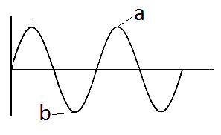

- ___________________:

- ___________________:

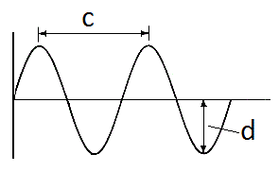
- _________________________:

- _____________________:

Frequency
The frequency of a wave is the number of ______________ _____________ that occur in one second. The units of frequency is _________________

How to calculate frequency:

Types of Waves
There are two main types of waves:

Transverse Waves:

Compression Waves:

Vocab: Amplitude, Wavelength, Crest, Trough, Frequency Homework p.143 #1-4,6-9

