Bohr Diagrams

The Bohr-model which is shown in Bohr diagrams shows an atom as a central _______________ with _______________ that orbit around it.

Niels Bohr used _______________ when designing his model. This model can be used as an approximation for the structure of lighter elements, but it runs into a few problems when we try to apply it to larger elements.

To get a better model we have to use the principles of quantum mechanics. We will use the Bohr model as an approximation for the first twenty elements.

What Information is in a Bohr Diagram?

A Bohr Diagram includes a specific set of information:

- The number of ________________

- The number of ________________

- The number of ________________

- Which ___________ __________ the ________________ are in

____________________ will be entered into the lowest (or first) energy level before moving onto later levels. The capacity of energy levels for ______________ follows a sequence where:
- The first level can hold up to ___ electrons
- The second level can hold up to ___ electrons
- The third level can hold up to ___ electrons
- The fourth level will hold any extras for the elements we may try

How to draw a Bohr Diagram
Sodium
- The atomic ____________ is the number of ___________

- The atomic __________ subtracted by the number of _________ will give the number of __________

- An element has the same number of electrons as it has protons

- Remember the order 2/8/8/…

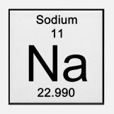
- Find out how many ___________ are in the element

- Find out how many ___________ are in the element

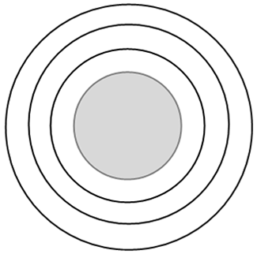
- Label the protons and neutrons in the nucleus

- Find out how many ____________ are in the element

- Fill in the energy levels until you have the correct number of electrons.

Examples:
Element:__________________

Element:__________________

Element:__________________

Element:__________________

Element:__________________

