History of the Periodic Table

1669 – _________________________________ discovers phosphorus

1680 – Robert Boyle also discovered __________________________ and made it public

1789 – Antoine Lavoisier tries grouping elements into the categories of ___________, ______________, ___________ and _____________

1809 – At least ____ elements were discovered by this time

1863 – John Newlands divided the 56 elements that were discovered into ____ different groups

1869 – Dmitri Mendeleev starts organizing the elements by ___________ ________. He left _______________ spots for unknown elements to fit in

1886 – Antoine Bequerel discovers radioactivity. Scientists can begin using this to examine the ________________ of atoms

1894 – Sir Ramsay and Lord Rayleigh discover the ____________ ________. They get organized as group 0 in the periodic table.

1911 – Earnest Rutherford discover that electrons revolve around a central ___________

1913 – Bohr discovers that electrons move around the nucleus at specific energy _______

1914 – Henry Moseley uses the number of _______________ of an element to give the elements an _________ _____________. This re-organizes the periodic table a bit and corrects some pieces.

1932 – James Chadwick discovers ____________ and completes the basis for the periodic table

1945 – Glenn Seaborg identifies the lanthanides and actinides.

Properties of the Periodic Table

Horizontal rows are called __________________. A period usually shows a repeating trend of changes from left to right.

Vertical columns are called ____________ or _______________. Groups share a common set of chemical properties and often have some shared physical properties

Notable Groups:

- Alkali Metals (Group 1):

- Alkaline Earth Metals (Group 2):

- Halogens (Group 17):

- Noble Gases (Group 18):

Blocks are wide sections of the periodic table where the elements share the majority of their properties. There are three blocks

 | State at room temperature | Appearance | Conductivity | Malleability and Ductility
Metals |  | Shiny | Good at conducting heat and electricity | Malleable and ductile
Non-Metals |  | Not shiny | Poor conductor of heat and electricity | Brittle and not ductile
Metalloids |  | Can be shiny or dull | May conduct electricity  Poor heat conductor | Brittle and not ductile
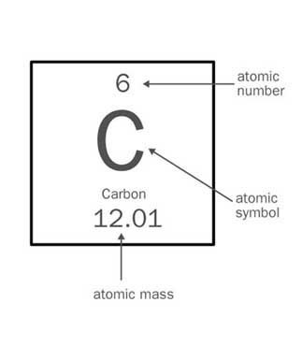
Reading the Periodic Table

Atomic Symbol/Formula:

Atomic Number:

Atomic Mass:

