Layers of the Earth

It is hypothesized that Earth started as a molten ball about _______________________. It cooled and the surface became solid. But as it cooled, ______________ substances have sunk towards the center of the earth and _____________ materials have moved towards the surface.
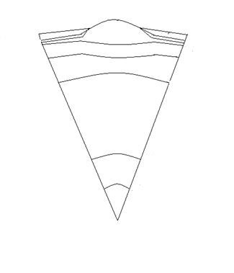

Crust

- __________________ of the earth’s top layer, called the Crust

- Is made from ___________ and ____________ which combine to form a group of rocks called silicates.

- There are two main types of rock on the crust. Oceanic plates of rock are usually _____________ where continental plates of rock are made of ______________.

The Mantle

- The mantle is the thickest layer of the Earth at about ___________________ thick. It makes up about ________ of the Earth’s volume. It is mostly solid and is divided into two sections.

- The ____________________ is composed mostly of molten rock with iron and magnesium. It tends to flow with the consistency of ______________________.

- The ____________________ begins at a transition zone of roughly ____________ deep. It is a solid dense material that contains more magnesium and iron.

Outer Core

- The layer below the mantle is the Outer Core. The outer core is ________________, which is different from all other layers of the Earth. It is ______________ thick and is a mixture of iron and nickel.
Inner Core

- The core is at the Earth’s center and has a radius of about _______________.

- The inner core is composed primarily of iron, though has some nickel too.

- The temperatures within the inner core range from ___________________. This is four times the melting point of iron, but the incredible pressures at the core keep it solid.

- Scientists believe that the inner and outer cores rotate at different speeds and may be responsible for Earth’s magnetic field.

Lithosphere

The crust and the ________________________________ are solid, these form the lithosphere. The name comes from the Greek word lithos, meaning ___________.

It ranges in thickness from _______________. The solid parts of our lithosphere float on the less rigid part of the Earth called the asthenosphere.

Asthenosphere

The zone directly below the lithosphere is the asthenosphere. The name comes from the Greek word asthenes, meaning weak.

The asthenosphere seems to be in _____________________. This motion creates stress on the rock layers above it, forcing __________ of the lithosphere to jostle against each other.

