Soil Ecology

Why is soil important in ecology?

What does a plant need from its soil?
- Firm hold to __________________ ___________

- Contain _____________________

- Contains up to ______________________________________________

- Allows ______________ to __________ _______ and _______________ through the soil

What is soil made of?

Sand

Silt

Clay

Organic Matter

Air

What types of soils are there?
A different mix of these ingredients will make different types of soils.
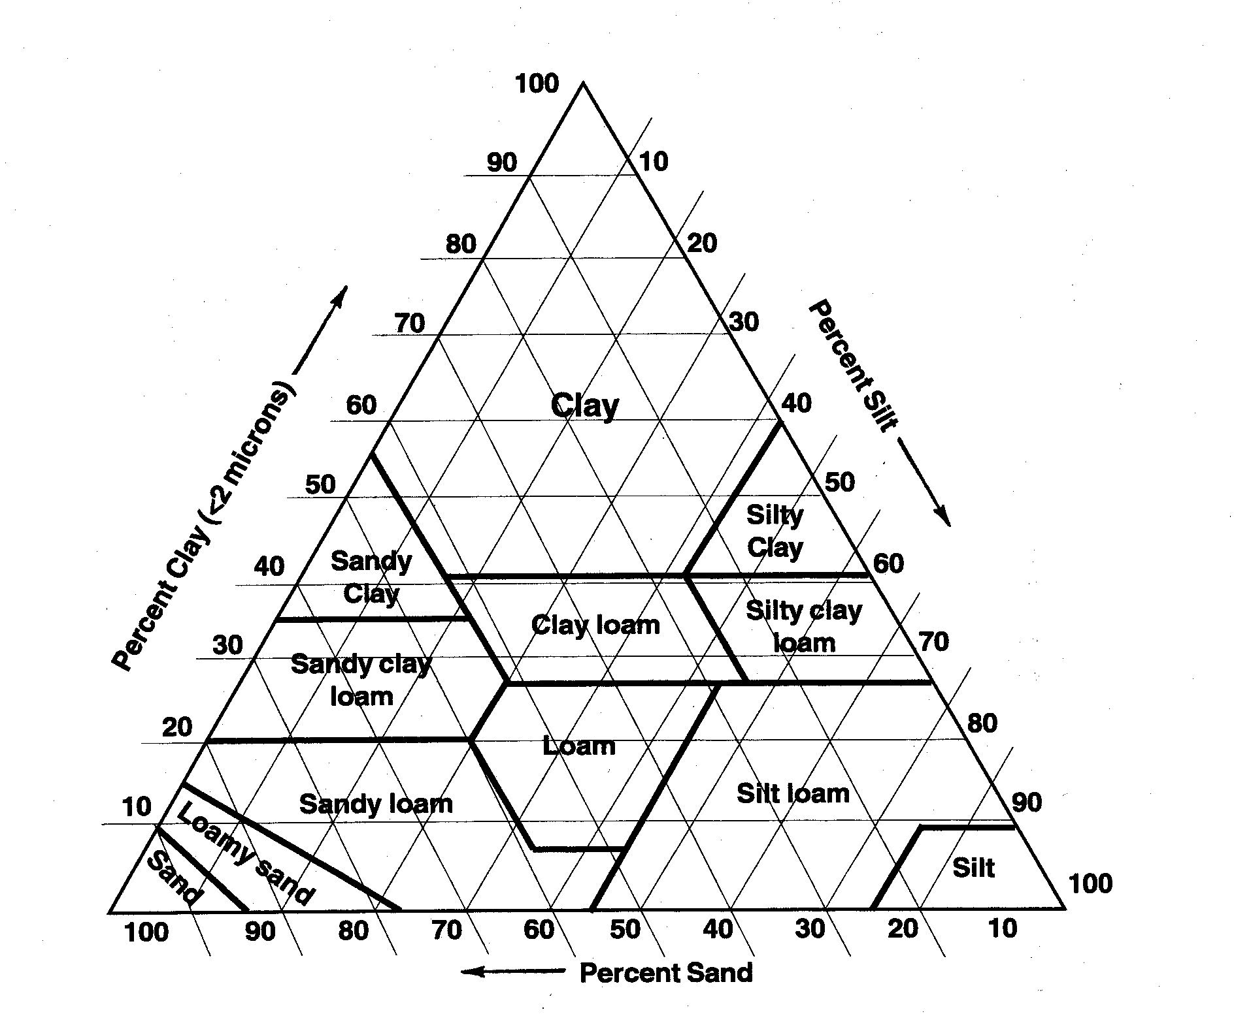

Who analyzes soil?
Soil scientists work for can work for ________________ and ______________________ governments, _____________________, and the private sector. The job of a soil scientist includes collection of soil data, consultation, investigation, evaluation, interpretation, planning or inspection relating to soil science. This career includes many different assignments and involves making recommendations about many resource areas.

Some careers that involve soil science are:
- Wetland specialist

- Watershed technician

- Hydrologist with Board of Health

- Environmental technician

- Soil and water quality specialist

- Agricultural Agent

- Landscaping business

- Farming

- Crop consultant

- Soil scientist, mapping and interpretation, for the federal government

- Research technician

- Conservation planner

- District marketing manager for an agricultural firm

- Crop production specialist

- Research scientist

