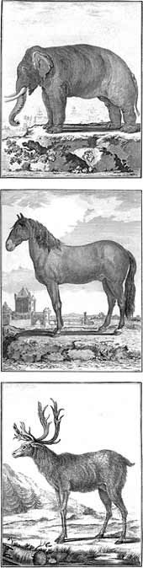
Natural Selection

Early Concepts of Evolution

Buffon – life can be divided into a number of distinct types based on the type of “particles” that are available. When they migrate, there will be new particles available in a new area, so they can make a new form of animal.

Lamarck – an organism’s behaviour can change its form and these changes can be passed to the next generation

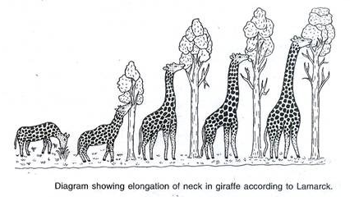

Natural Selection
- Basic mechanism of evolution along with __________________, __________________, and __________________ _________
Darwin’s idea of evolution by natural selection is simple, but often misunderstood.

- There is variation in _______________________
  - For example, there may be some beetles that are green and some that are brown

- There is ______________________ _______________________
  - Since the environment can’t support unlimited population growth, not all individuals get to reproduce to their full potential.
  - Beetles get eaten by birds and since green beetles are easier to see than brown beetles, more green beetles get eaten

- There is __________________________
  - The surviving beetles have baby beetles. Brown beetles will have brown beetle babies and green beetles will have green beetle babies

- End result
  - Since the green beetles are eaten more than the brown beetles there will be more brown beetle survivors. The brown beetle becomes more common than the green beetle. With more generations of beetles being eaten and reproducing there will eventually be no more green beetles.

